OUTPUT: NODE CREATED AND VALUE INSERTED

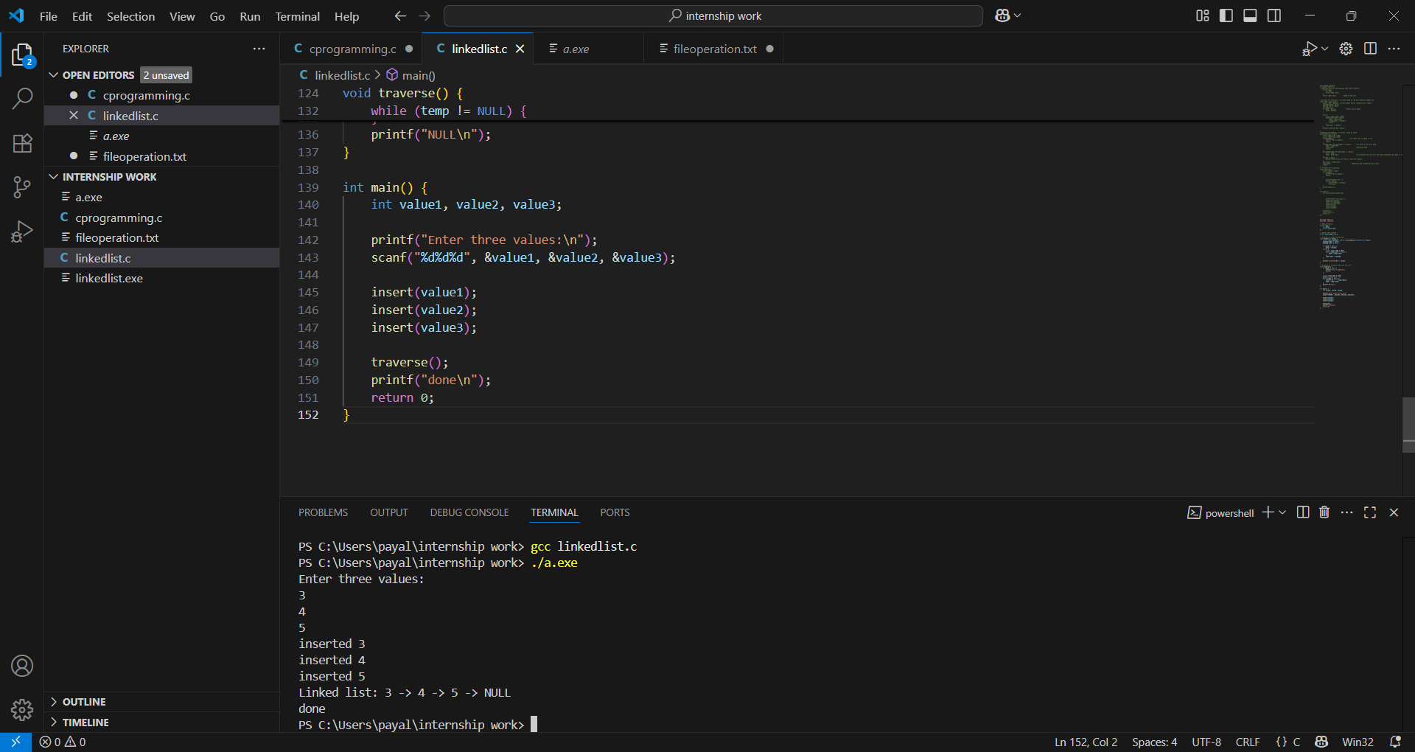

OUTPUT: Deletion of node

